GPS DIO:

Based on the following schematic, I have implemented the GPS part of the system.

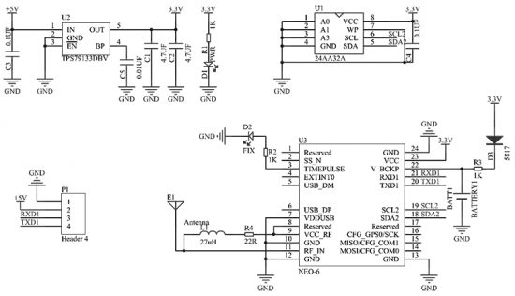

The battery charging circuit has been made using the manufacturers recommendation:

<https://www.sii.co.jp/en/me/battery/support/charging-circuit1/>

schottky diode with 0.3 FVD and 1kohm resistor.

The power supply is the same as with all the other modules.

Buffers are used, as per the integration manual for SPI communication

Other useful links:

Gps module tutorial: <https://lastminuteengineers.com/neo6m-gps-arduino-tutorial/>

UBlox hardware integration manual: <https://www.u-blox.com/sites/default/files/products/documents/LEA-NEO-MAX-6_HIM_%28UBX-14054794%29_1.pdf>

ESP Part:

Bitna je boja nekog led al ne znam kojeg

USABLE PINS:

D1 = GPIO5

D2 = GPIO4

D6 = GPIO12

D7 = GPIO13

D3 = GPIO0

* **digitalWrite**did NOT work with GPIOs 6, 7, 8, 11, and ADC (A0)
* **digitalRead** did NOT work with GPIOs 1, 3, 6, 7, 8, 11, and the ADC (A0)
* **analogWrite**did NOT work with GPIOs 6, 7, 8, 11, and ADC (A0) (GPIOs 4, 12, 14, 15 have hardware PWM, and the others are by software)
* **analogRead**worked only with the ADC (A0)
* **6**, **7**, **8**, **11**do NOT work for the above four commands

LORa:

Connections with the ESP are temporary dok ne nadjes datasheet kako treba

Nije bas jasno kako cu SPI koristiti, koji CS pin za jedan koji za drugi

ESP<>LORA

References:

Lora power consumption

<https://iopscience.iop.org/article/10.1088/1757-899X/318/1/012053/pdf>

thermal calculations <https://www.ti.com/lit/an/slva079/slva079.pdf?ts=1619639522430&ref_url=https%253A%252F%252Fwww.google.com%252F#:~:text=In%20addition%2C%20the%20voltage%20difference,regardless%20of%20the%20load%20conditions>

https://www.ti.com/lit/an/snva036b/snva036b.pdf

JTAG CONNECTOR PINOUT [https://media.digikey.com/pdf/Data%20Sheets/Espressif%20PDFs/Intro_to_the_ESP-Prog_Brd_Web.pdf 07.05.21 7:36](https://media.digikey.com/pdf/Data%20Sheets/Espressif%20PDFs/Intro_to_the_ESP-Prog_Brd_Web.pdf%2007.05.21%207:36)

Useful conventions https://www.signalintegrityjournal.com/blogs/12-fundamentals/post/1207-seven-habits-of-successful-2-layer-board-designers